WEEK 8 NET731 Practical’s

TASK 1
Create Azure Budget Alerts
Budget option
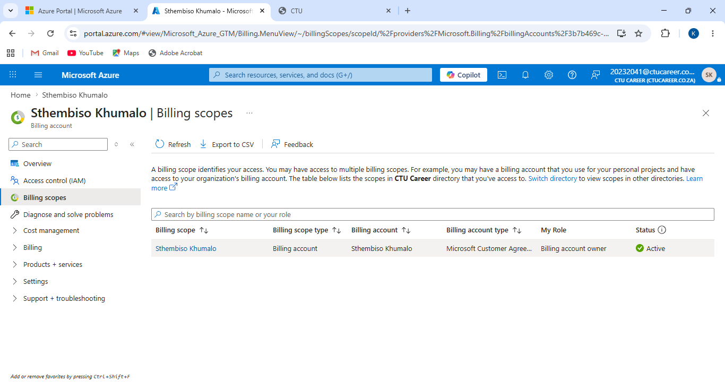

Config the budget amount
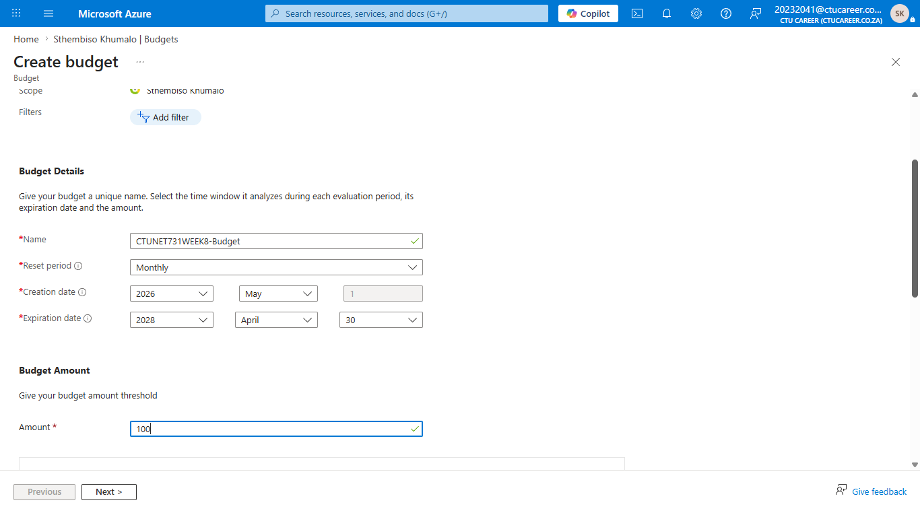
Config Alert conditions
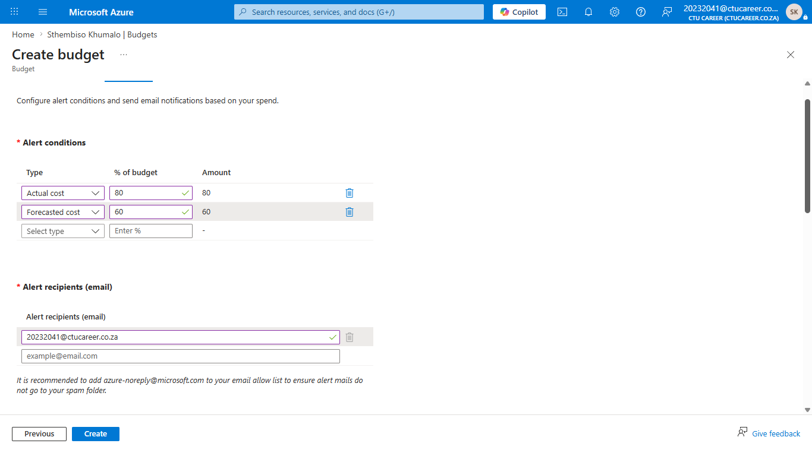

TASK 2
I couldn’t get the graph and pie chart for cost services.
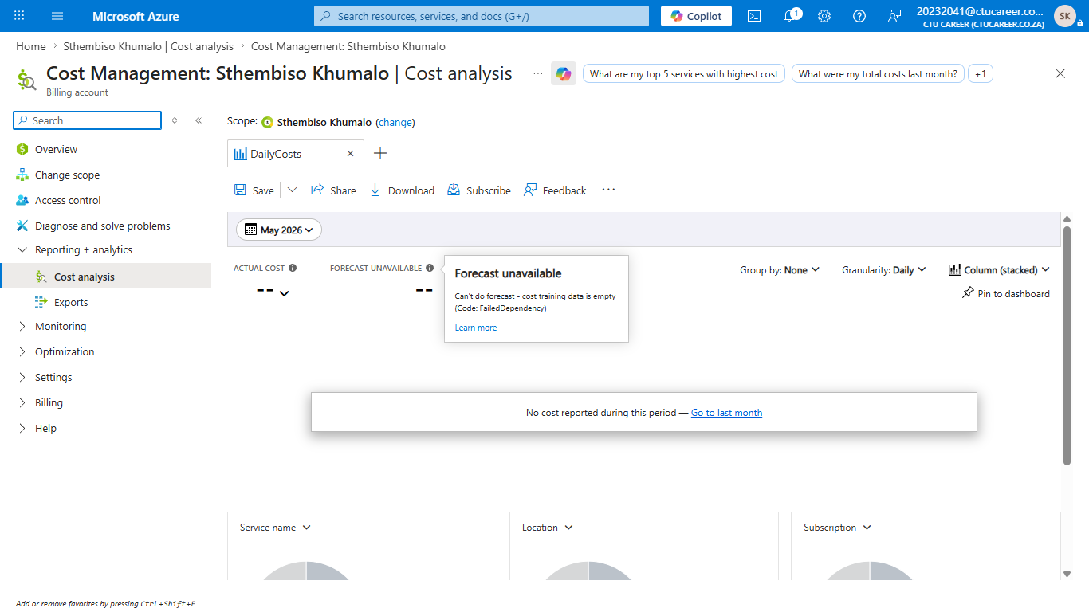

Reflection Questions
17. I managed to create the Azure budget alerts, but I couldn’t get the cost analysis such as the graphs and pie chart.
18. There could be more resource groups, and the costs would be high.
19. The cost allocation under settings in the Cost Management overview.

